TABLE OF CONTENTS:

1. BRIEF DESCRIPTION: 3
2. BLOCK DIAGRAM: 3
3. WORKING: 3
4. CIRCUIT DIAGRAM: 3
5. Component Map: 4
6. HARDWARE: 4
7. SOFTWARE: 4

LIST OF FIGURES:
Figure 1: BLOCK DIAGRAM 3
Figure 2: CIRCUIT DIAGRAM 3

LIST OF TABLES:
Table 1: Component List 5

AUTOMATIC TOLL COLLECTION USING RF:

Document Created By: Ali Raza.
Document Creation Date: 27 Jul ‘09
Update History:
Updated on | Updated By | Sections Updated

AUTOMATIC TOLL COLLECTION USING RF:

1. BRIEF DESCRIPTION:
The objective of this project is to automate the toll collection system using RF & µC.

2. BLOCK DIAGRAM:
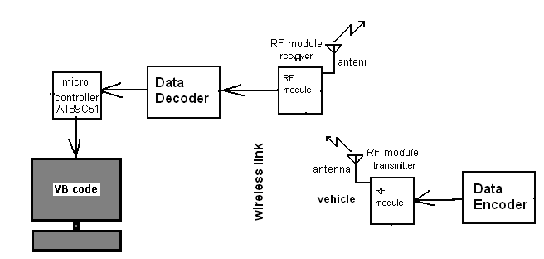
Figure 1: BLOCK DIAGRAM

3. WORKING:
At every toll collection center, RF receiver will be interfaced with PC.Each vehicle will be provided RF Tx that will transmit its identity whenever it will pass through this toll collection centre. In data base of the PC, information of the vehicle will be stored. (Vehicle no. account status, etc.). The RF Rx at toll collection centre will receive the data from vehicle & deduct the amount of toll as per the tariff. Database will be designed in VB.
µC will be used with RF Rx. Programming for µC will be done ‘C’.
Camera will be installed at toll collection center which will take the image of the vehicle (vehicle no. or photo of the driver) for security purpose.

4. CIRCUIT DIAGRAM:

Figure 2: CIRCUIT DIAGRAM

5. Component Map:
COMPONENT INSTANCE | COMPONENT TYPE | COMPONENT VALE | NO. | COST.
 | IC | AT89C51 | 1 | 60
 |  | MAX232 | 1 | 35
 | IC SOCKET | 40 PIN | 1 | 10
 |  | 16 PIN | 1 | 6
 | RECTIFIER | DB107 | 1 | 5
 | DIODE | 1N4148 | 1 | 1
 | VOLT.REG | 7805 | 1 | 7
 | PULL UP | 9A472G | 1 | 9
 | PRESET | 10K POT | 3 | 5
 | RESISTER | 8K2 | 1 | 1
 |  | 10K | 1 | 1
 |  | 1K | 1 | 1
 | CAP. | 10µF63V | 5 | 5
 |  | 100µF50V | 1 | 5
 |  | .1PF | 5 | 1
 |  | .33PF | 2 | 1
 |  | 1000µF25V | 1 | 5
 | CRYSTAL | 11.0592 | 1 | 10
 | CONNECTOR | 2 PIN | 6 | 5
 | RELI. | 9 PIN | 1 | 10
 | RELI. | 16 PIN | 1 | 15
 | DISPLAY | 16X2 | 1 | 125
 | SWITCH | RESET | 3 | 5
 |  | SLID | 1 | 5
 | LED | 1 | LED | 1
 | RF MODULE. | 315MHZ. | 1PAIR | 300
Table 1: Component List

6. HARDWARE:
- AT89C51 microcontroller
- RF module
- MAX 232 for level (protocol) conversion

7. SOFTWARE:
- Kiel uv3 for Embedded ‘C’
- Flash magic for code downloading
- Visual basic for PC interfacing

